Midterm Project Report

*Xiongfeng Wang*

**Introduction**

This project will perform a supervised machine learning process on the Google play store Apps dataset1 using rating as the target variable. This is a regression problem considering that the rating scales from 1 to 5, decile between integers.  
This is an interesting task because it allows us to predict the rating of an App with certain features. For the existing Apps, comparing the prediction result with the true value can assist in finding outliers with specialty. For recently developed Apps, a precise prediction result reveals the feedback in the future which saves the value of time, or gives people a hint about the App's customer experience.

The dataset initially has 10841 samples with 1 key (App), 1 target variable (Rating) and 11 features. For description and property, please refer to the table below.

There are plenty of public projects on this dataset, mostly focusing on EDA, data visualization, machine learning on rating prediction and data analysis. The top voted notebook4 analyzed almost every column of the dataset except for the version ones and discussed some relationship between certain columns, for example, Users prefer to pay for apps that are light-weighted. The notebook's conclusion is neat but market-related practical. A trending notebook5 plots the data with different plotting packages but just like most other visualizations, author discussed the relationship between rating and one feature individually. The top voted machine learning notebook2 provides integer encoding RFR model, dummy encoding SVR model and random forest regressor model but cannot conclude which model has the best predictive.

**EDA**

Caption:

The Distribution of Category plot shows the that samples in Family and Game category is way higher than others, later in the Distribution of Category and Subcategory3 we will find out the reason for this is that there are plenty of subcategories under these two groups.

One problem with the data set is that feature ‘Genre’ actually stands for the subcategory of the App if applicable. The Distribution of Category and Subcategory plot clearly reveals the component of the main category. As we can see for Family and Game, there are more subcategories in it.

The Scatter Matrix for float & int variables plot shows the relationship between variables with the type of float & int. If we look at the histogram for Distribution of Size, Price and Days, which are not included here, we will find out the varibable is quite imbalance, x-axis must be semiloged to show a fair plot. This explains why some of the matrix plot has heavy skewness. This suggests that we should apply StandardScalerEncoding later.

I use bin = 39 for the Rating over Category graph because of the rating scale I mentioned above, we noticed that Family and Gaming seems to have a higher average score than the overall rating.

**Data Processing**

This is not an IID dataset because clearly there are group structures in the dataset: Category and Subcategory. Also this is not a time series dataset because even though for very small amount of Apps, there are samples for different version of it and the rating might vary, the proportion is too small to be consider as a general feature. Most of the Apps with different version only differ in number of reviews by around 1%.  
Considering there are 8893 samples with a valid target features, the size of the data set is fair to apply a 8-1-1 split. Category with lowest counts is 42 for Beauty, 9 categories' count below 100, and only 2 categories' count above 800, so the 8-1-1 split is rational because we don't need to worry about group in train/test set should not appear in the other. We can implement plenty of n_split on the dataset.  
Since there's an obvious group structure, I will choose GroupShuffleSplit to split the dataset. I choose GroupShuffleSplit over GroupKFold because the data set is also imbalance as we can see from the distribution of categories, or some other features.

For Encoder selection and reason, please refer to the table below.

|  |  |  |  |  |  |
| --- | --- | --- | --- | --- | --- |
|  | Variable | Description |  | Encoding | Note on reasons |
| Key | App | Name of the App | Categorical | No Encoding |  |
| Feature | Category | Category of the App | Categorical | OneHotEncoder | No order |
| Reviews | Number of reviews | Numerical | StandardScaler | Skewness |
| Size | Size of the App | Numerical | StandardScaler | Skewness |
| Installs | Scale for number of installs | Categorical | OrdinalEncoder | With order |
| Type | Free or Paid | Categorical | OneHotEncoder | No order |
| Price | Price of the App | Numerical | StandardScaler |  |
| Content Rating | Restriction rating | Categorical | OneHotEncoder | No order |
| Genres | Category; Subcategory | Categorical | N/A (see Subcategory) |  |
| Last Updated | Last updated date in Month DD, YYYY | Numerical | N/A (see Days) |  |
| Current Ver | Current verison of the App | Categorical | N/A |  |
| Android Ver | Android version that supports | Categorical | OneHotEncoder | No order |
| Subcategory | Subcategory | Categorical | OneHotEncoder | No order |
| Days | Day since last update | Numerical | StandardScaler | Skewness |
| Target | Rating | Rating for the App | Numerical | StandardScaler |  |

**Figures**

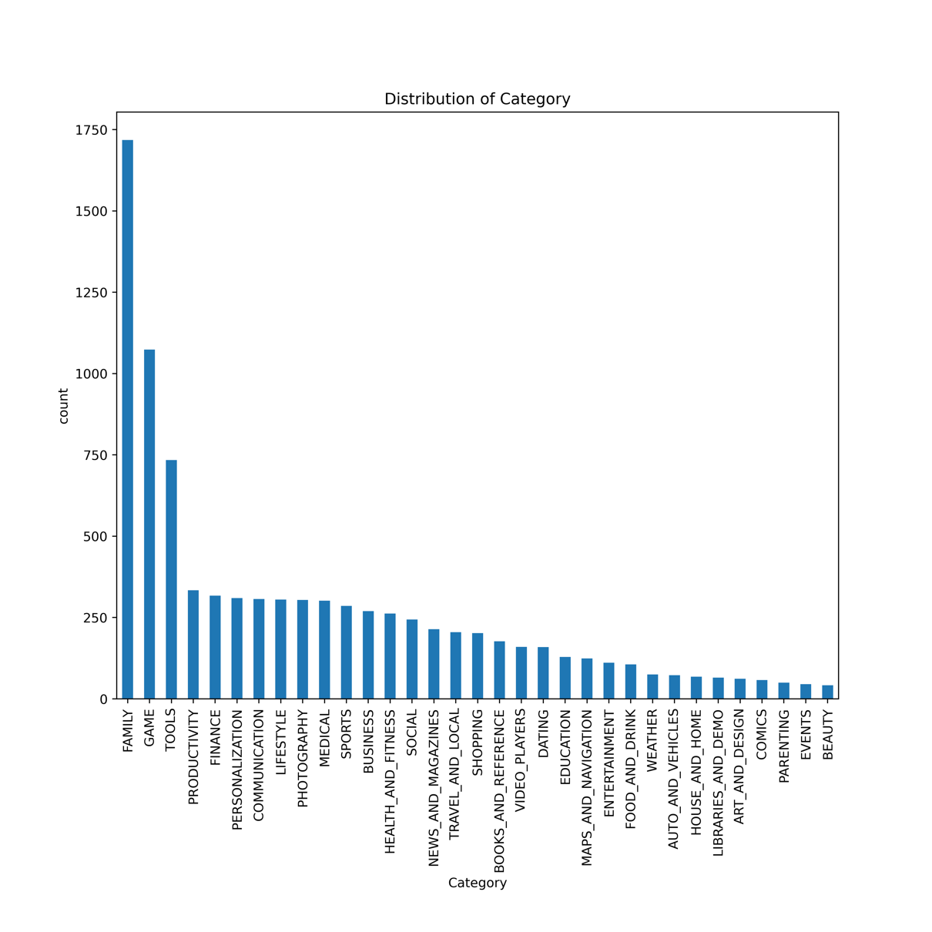

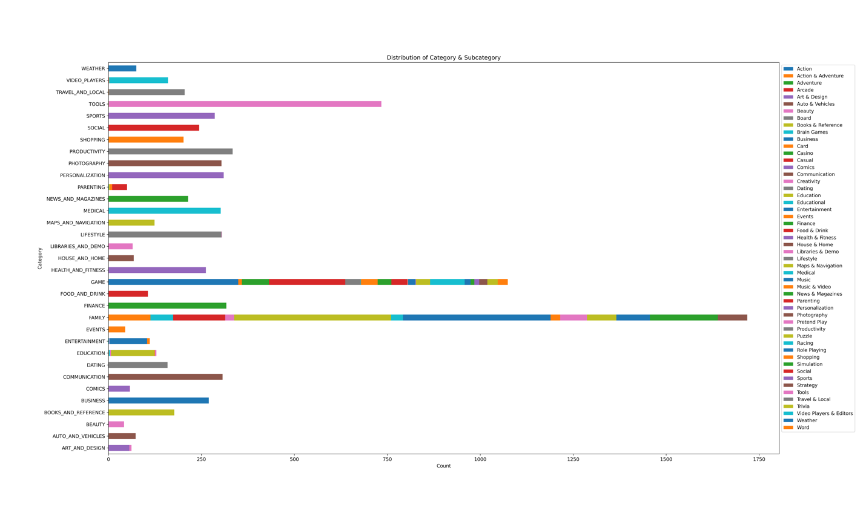

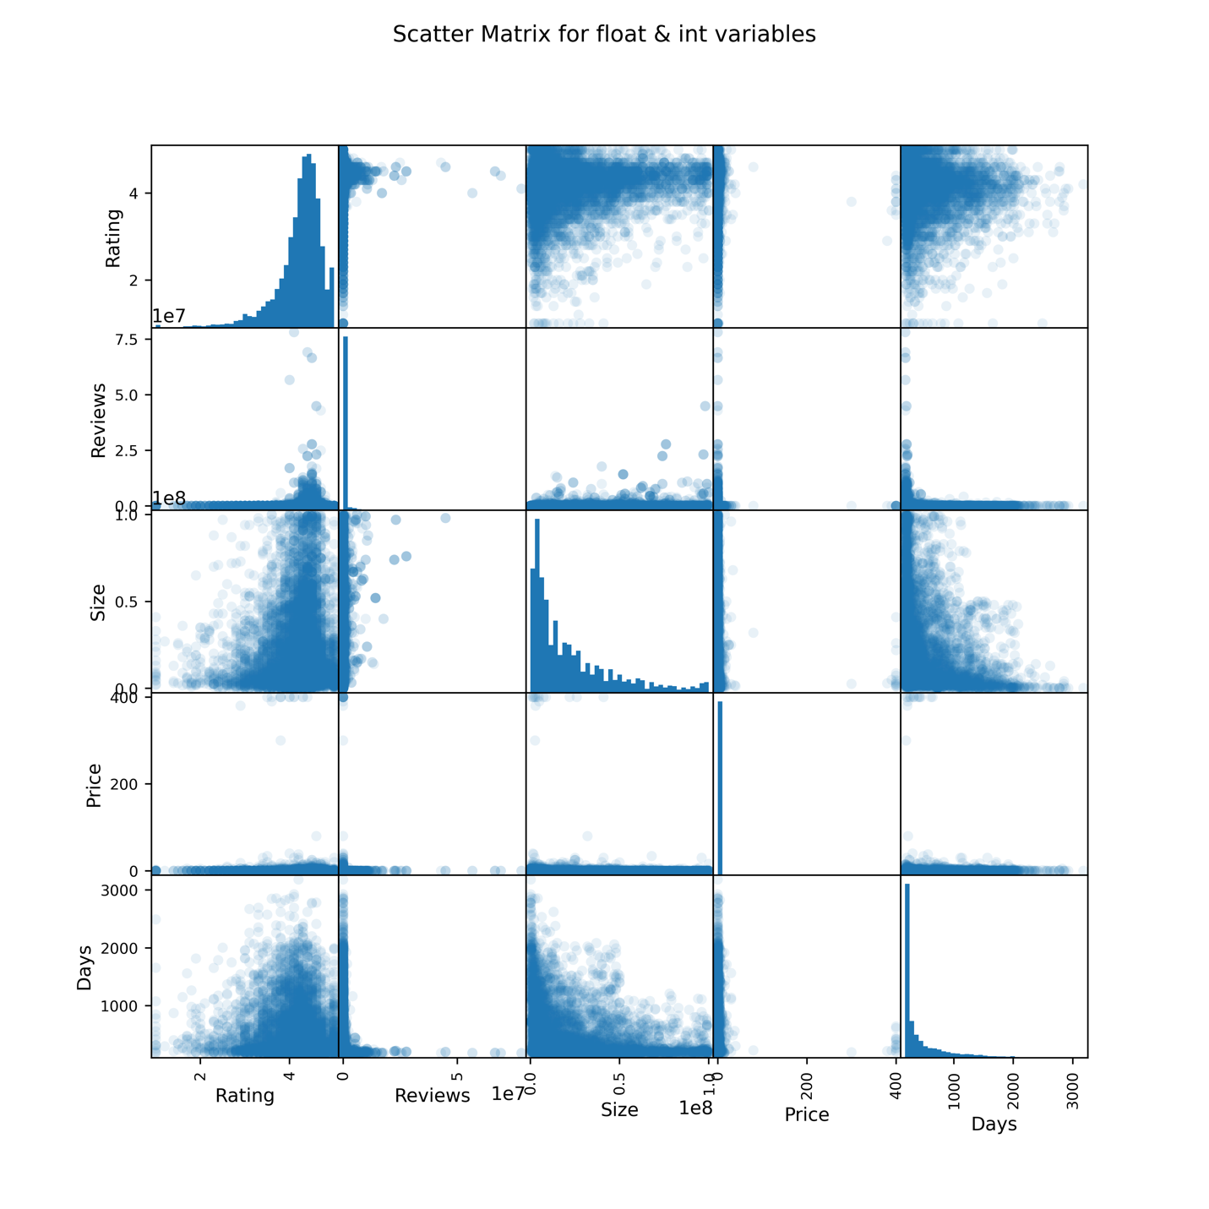

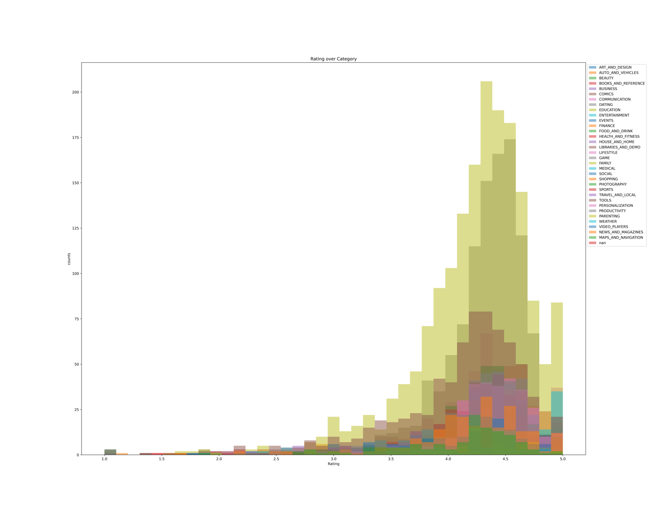

**Github Repository**

https://github.com/XiongfengWang/1030project

**Reference**

1. Gupta, L. (2019, February 03). Google Play Store Apps Dataset. Retrieved October 13, 2020, from https://www.kaggle.com/lava18/google-play-store-apps
2. Jemseow, J. (2018, September 27). Machine Learning to predict app ratings. Retrieved October 13, 2020, from https://www.kaggle.com/jemseow/machine-learning-to-predict-app-ratings
3. Siddiqi, S. (2018, September 28). Google Play Store Apps - Data Cleaning. Retrieved October 13, 2020, from https://www.kaggle.com/sabasiddiqi/google-play-store-apps-data-cleaning
4. Gupta, L. (2018, September 19). All that you need to know about the Android market. Retrieved October 13, 2020, from https://www.kaggle.com/lava18/all-that-you-need-to-know-about-the-android-market
5. Jha, R. K. (2020, January 27). ML to Visualization &amp; Prediction of App Ratings. Retrieved October 13, 2020, from https://www.kaggle.com/rajeshjnv/ml-to-visualization-prediction-of-app-ratings